**Training Manual of Magnus Opto**

* Login page of Magnus ERP Next system

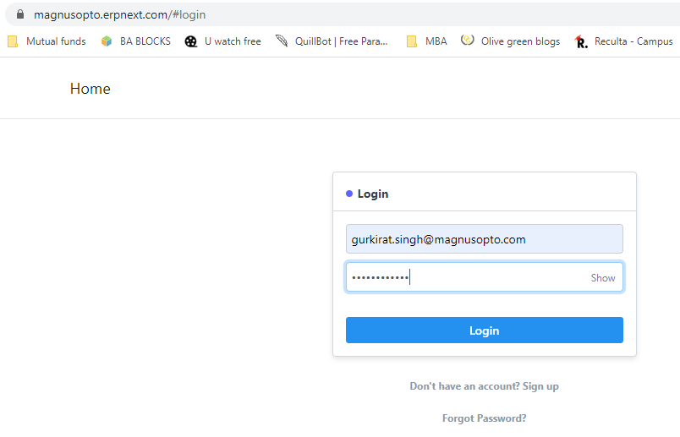

* For Creating Lead click on the option marked in a rectangular block or you can also type Lead List in the search box and then click new

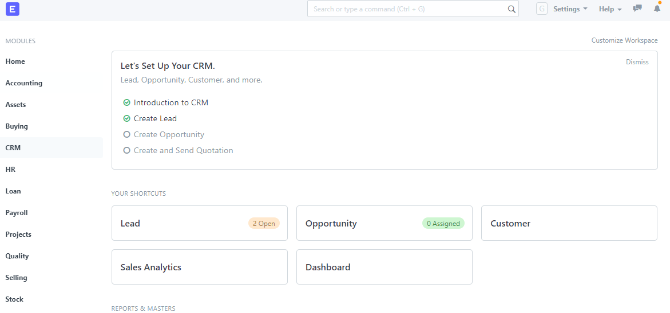

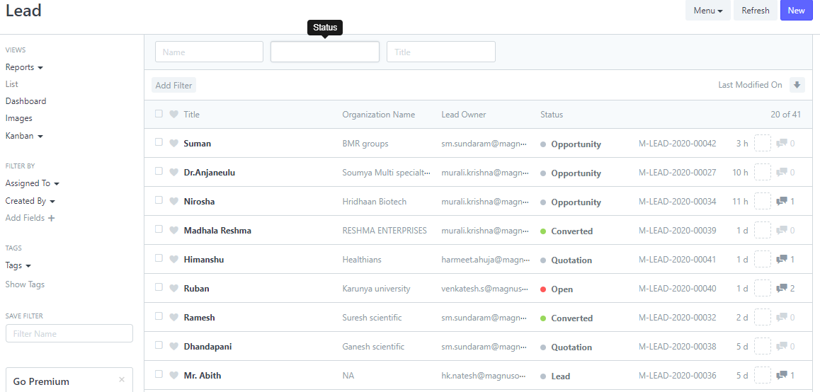

* Start filling the details of lead while asking from him/her or either details can be captured from some other source such as website / campaign etc

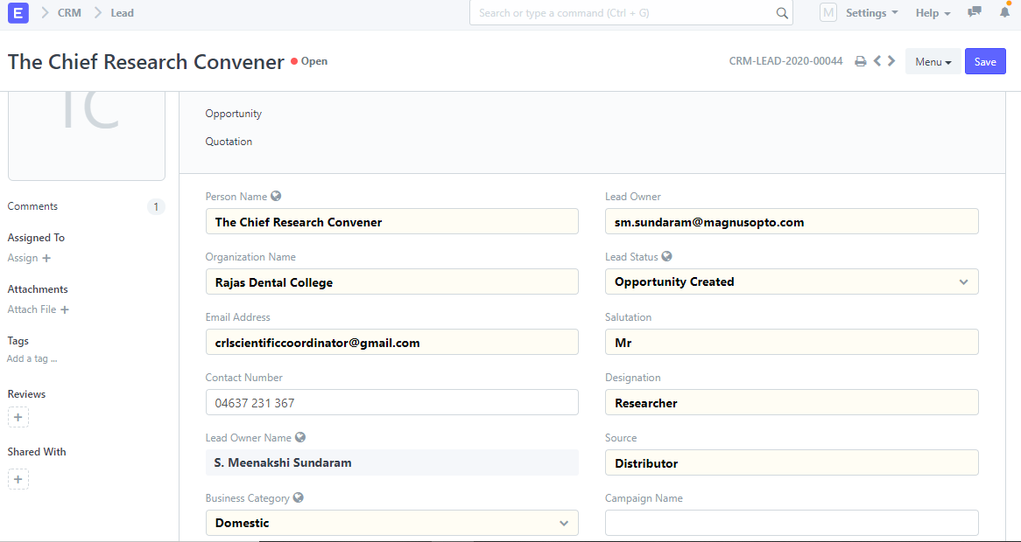

* This Field has 5 options :

1. Lead
2. Opportunity Created
3. Open
4. Future Prospect
5. Do Not Contact

It has been automated on the basis of the answers selected in the next Section names as “Categorization”. If the Lead category is either hot or warm then the status will automatically select “Opportunity Created” and in case of cold Lead it will change to “Open”. Make it a practice to not to select value of the field from its option, try answer the question under “Categorization” section.

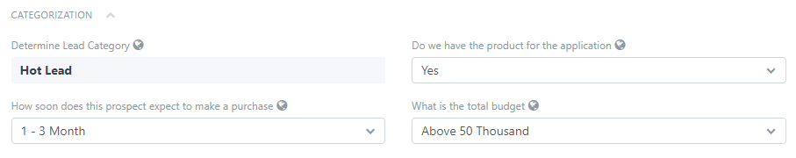

* In the below image, Business Category had 2 options: Domestic and International. Magnus has 70% - 80% Domestic Business and rest their business deals in International domain.
* If “International” is chosen then the 2 sections will hide from the page i.e. “Categorization” and “More Information”.

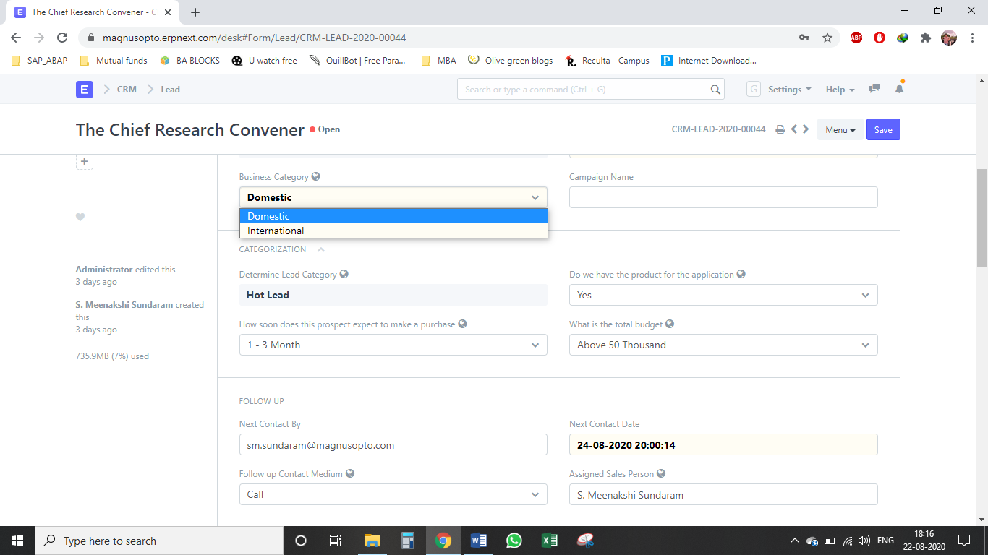

* Few fields on the page has been kept as mandatory field which will prompt the user to enter the value or select the option otherwise the page will notify to enter the value.

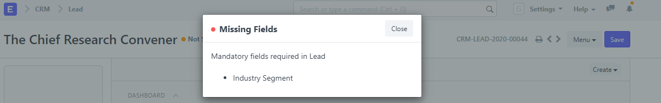

* All the fields in the below image are kept mandatory fields.

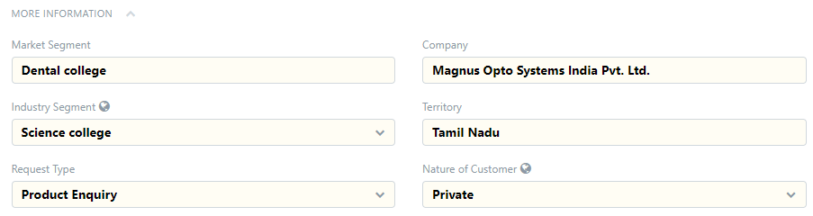

**OPPORTUNITY STAGE**

* Opportunity can be created from 3 ways. 2 are available in the below image and the 3rd option is present in the next image.

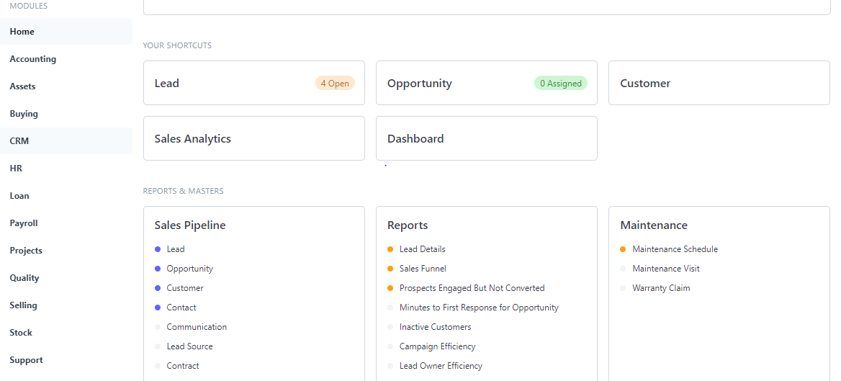

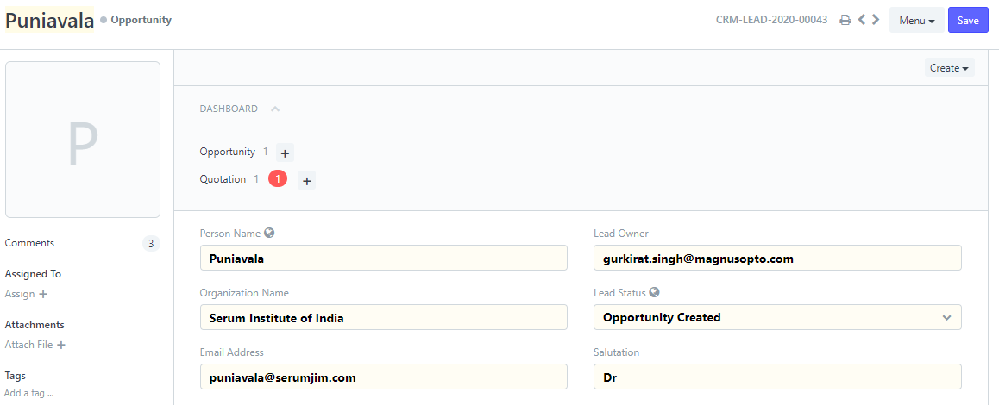

* In Opportunity stage, for viewing the customer’s mobile no one needs to re-enter the Lead No.
* Under sales section of opportunity, we need to select opportunity stage that we will automatically provide the probability of conversion and one needs to enter the opportunity amount based on an estimation of discussion.

|  |  |
| --- | --- |
| **Once an opportunity is created, then below stages will be applicable** | **Win probability** |
| Prospect stage | 10% |
| Present the solution | 30% |
| Overcome objections & Quotation handling | 70% |
| Order won or loss | 100%/0% |

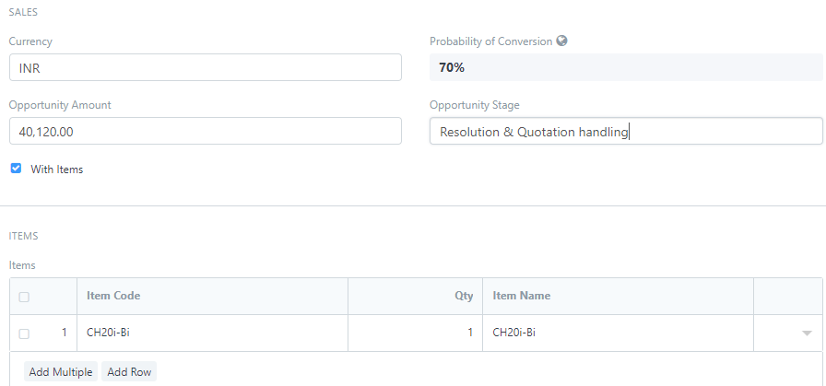

* In case of “Order Loss” in opportunity stage we need to fill two more fields that will pop up once we select the option “Order Loss”.

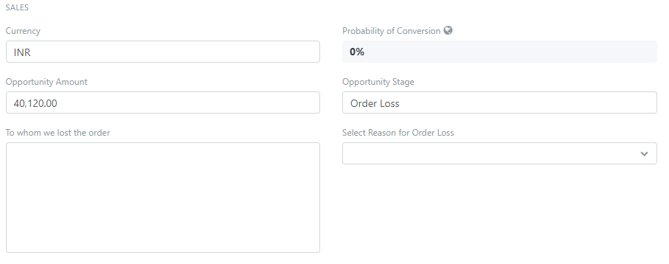

**NOTE: In case of Order Loss / Won, a mail will be sent to the person who is following up the lead where Manish Kathuria and Harmeet Ahuja will be kept in CC.**

**QUOTATION STAGE**

* Quotation can be crated either typing “Quotation List” in ERP’s search bar or can be created through step available in below step.

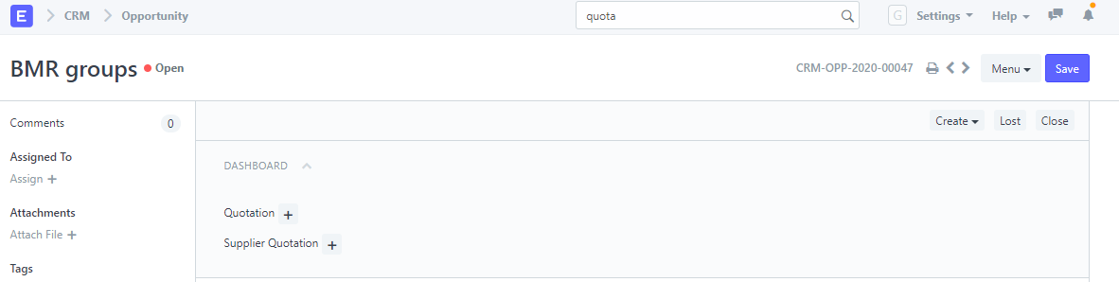

* We need to select who is selling the items which is available in “Sold By” option which will impact the terms and conditions automatically for “Distributor” and “Direct”.
* If “Distributor” is selected then 2 fields will open up one is to select the distributor name and to select the type of distributor i.e. “Super” or “Normal”.
* And this selection of distributor type will automatically fill Disc % in Item table. For Normal it is 25% and for Super it is 30% by default. **However, this Disc% field is editable.**

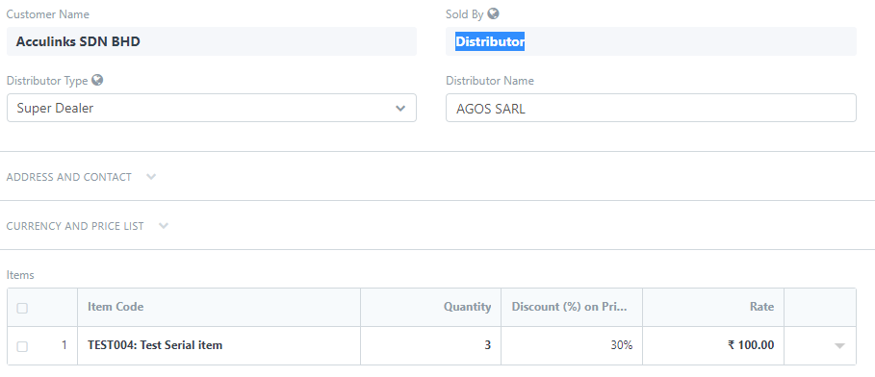

**Note: For Discounts more than 25% on items the approval for saving the quotation will be sent to Mr. Manish Kathuria.**

**SALES ORDER STAGE**

* Sales order can be created in 3 ways: one is through typing in “Sales Order List” in ERP’s Search box and then clicking “New” and rest 2 are mentioned in below pic.

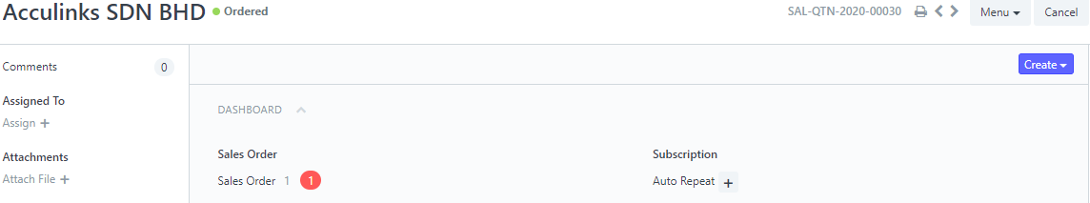

* In beginning of sales order, Mode of dispatch, Partial Shipment, Customer’s PO and Customer’s PO date is supposed to be filled and if for the order the payment is done in advance the checkbox needs to be ticked which will pop up other relevant fields.
* For viewing print of Sales Order one needs to be clicked on the **below button**

